|  |
| --- |
| EE495/CME495 |
| Robotic Positioner Capstone Interim Report |
| Revision 1 |

|  |
| --- |
| Thomas Hu, Jordan Smith, Jason Wong  12-5-2019 |

Contents

1 Introduction 4

1.1 Purpose 4

1.2 Scope 4

1.3 Document Organization 4

1.4 Document Identifier 4

1.5 Applicable Documents 5

1.6 Revision History 5

1.7 Abbreviations and Acronyms 5

2 Problem Definition 6

2.1.1 Problem Description 6

2.1.2 Background 6

2.1.3 Scope 7

2.1.4 Objectives 7

2.1.5 Constraints 7

3 System Requirements Matrix 8

4 System Alternatives 13

4.1 System Alternative Generation 13

4.1.1 Logic Control Device Selection 14

4.1.2 Motor Selection 16

4.2 Conclusion 17

5 System Design 18

5.1 System Design Description 18

5.1.1 General 18

5.1.2 System Description 19

5.2 Detailed System Design 21

5.2.1 Control Box 21

5.2.2 Operator Panel 21

5.2.3 Rotator 21

5.2.4 A Frames 22

5.2.5 Technical Specifications 22

5.3 System Operation 23

5.3.1 System Software 23

5.3.2 System Operations 25

5.3.3 E-Stop Functionality 27

6 System Test Plan 28

6.1 Verification Process 28

6.1.1 Introduction 28

6.1.2 Verification Methods 28

6.1.3 Verification Strategies 28

6.1.4 Doepker Industries Notification 29

6.2 Levels of Testing 30

6.2.1 Overall Test Process 30

6.2.2 System-Level Testing 30

6.2.3 Required Test Equipment 31

6.2.4 Anomalies – Log Items 31

6.3 Factory Acceptance Testing 32

6.3.1 Introduction 32

6.4 Doepker Industries Robotic Positioner Test Procedures 33

6.4.1 Purpose 33

6.4.2 Test Failures 33

6.4.3 Test Preparation 33

6.4.4 Detailed Procedures 36

7 Project Planning 46

7.1 Introduction 46

7.2 Risks to Project Performance/Schedule 46

7.3 Milestones 46

7.4 Gantt Chart 47

7.5 Work Breakdown Structure 48

7.6 Prototype Costs 51

7.7 System Bill of Materials 51

7.8 Project Budget 52

7.9 Remaining Budget 52

8 References 53

9 Appendix A 54

**Table of Figures**

Figure 5‑1 - System Block Diagram 18

Figure 5‑2 - System Model 19

Figure 5‑3 - Software State Diagram 23

Figure 5‑4 - Operator Panel Layout 25

Figure 5‑5 - System Rotation Direction 26

Figure 6‑1 - System Testing Process 30

Figure 6‑2 - Test Setup 34

Figure 7‑1 - Project Gantt Chart 47

**Table of Tables**

Table 3‑1 System Requirements Matrix 9

Table 5‑1 - System Specifications 22

Table 5‑2 - Behaviour of LED and Buzzer for each System State 27

Table 6‑1 - Test Equipment 31

Table 6‑2 - Test Equipment 33

Table 7‑1 - Project Milestones 46

Table 7‑2 - Work Breakdown Structure 49

Table 7‑3 - Cost of Prototyping 51

Table 7‑4 - Bill of Materials 51

Table 7‑5 - Project Billable Hours 52

# Introduction

## Purpose

This document is used to present the current progress as of December 5, 2019 for the Doepker Industries Robot Positioner project for the 2019-2020 session of EE495/CME 495.

## Scope

This document addresses the following aspects of the Doepker Industries Robot Positioner project:

* **Problem Definition**
* **System Requirements Matrix**
* **System Alternatives**
* **System Design**
* **System Test Plan**
* **Project Planning**

## Document Organization

The following sections in this document are organized as follows:

* **Section 2** – introduces the problem description of the system. The background, scope, and main objectives/constraints are discussed in this section.
* **Section 3** – introduces the requirements of the system. All system requirements are described, in addition to how they will be verified.
* **Section 4** – includes discussion on the types of subsystem components considered during the process of deciding on a final system design. The selection of the components is justified in this section.
* **Section 5** – introduces the system design of the Robotic Positioner. A system overview is provided, along with descriptions of the system functionality and operation.
* **Section 6** – describes the verification process of the system. Formal system test procedures are attached to this section.
* **Section 7** – provides a project management overview of the project so far. A review of the project thus far is included, along with the remaining tasks left before project completion.
* **Appendix A** – provides technical drawings of the circuitry of the system.

## Document Identifier

This document is identified as:

**CD6 – EE495/CME495 Robotic Positioner Capstone Interim Report**

## Applicable Documents

Applicable documents include:

**CD1 – EE495/CME495 Robotic Positioner Problem Definitions Document**

**CD2 – EE495/CME495 Robotic Positioner Project Plan Document**

**CD3 – EE495/CME495 Robotic Positioner System Requirements Document**

**CD4 – EE495/CME495 Robotic Positioner System Design Document**

**CD5 – EE495/CME495 Robotic Positioner System Test Plan**

## Revision History

|  |  |  |
| --- | --- | --- |
| **Date** | **Revision** | **Changes** |
| December 5, 2019 | 1 | Initial Revision |
|  |  |  |

## Abbreviations and Acronyms

|  |  |
| --- | --- |
| E-stop | Emergency stop |
| FAT | Factory Acceptance Test |
| FPGA | Field Programmable Gate Array |
| GPIO | General Purpose Input/Output |
| Nm | Newton-meter |
| PLC | Programmable Logic Controller |
| RPM | Rotations per minute |
| TBD | To be determined |
| VAC | Volts Alternating Current |
| VDC | Volts Direct Current |

# Problem Definition

### Problem Description

Doepker Industries is looking into transitioning its hydraulically/mechanically powered welding positioner units to units which operate entirely on electrical power. This will benefit Doepker Industries by increasing production output while maintaining quality while being safer to operate.

Doepker Industries requests a design for a rotator by December 6, 2019 which can be used to rotate equipment for welding, blasting, painting, or finishing that can be mounted to their existing rotator frames. The design is required to be capable of rotating a load to any degree, with the ability to automatically rotate the load to pre-defined angled positions. This rotator will help operators by allowing them to work with equipment at a less awkward angle. This will also help Doepker Industries save costs by allowing them to produce as many of these units as desired at a lower cost than if bought from a vendor. The client has also requested that the rotator be user-friendly and is operated using physical buttons.

### Background

Welding positioners are used to reposition work pieces to access different angles. They allow precise placement and reduce angular momentum with controlled rotation. To achieve rotation on these items, it is often necessary to incorporate gear reduction to slow down the speed of rotation and reduce fatigue on the prime mover.

The current positioners used by Doepker Industries are hydraulically/mechanically powered which then are reduced in speed using a gearbox. The company would like to update their rotators with an electric drive system to increase accuracy and allow for recallable positioning.

A few possible electric drives exist that can work in this application, as shown below. The electric drive selection is explored in more detail in Section 4 :

* **Servo Drives** – capable of precise motion and provide a closed loop feedback, meaning the position of the rotor is always known. They can run at high RPM but lose torque at higher RPM. Speed is controlled by utilizing a drive controller and a position encoder.
* **Three Phase Induction Motors –** a simple and inexpensive type of motor. Control is achieved using a variable frequency drive. They do not have closed loop feedback, meaning that the placement of the rotator would require external sensors.
* **Stepper Motors** – rotate in programmable microsteps and are capable of high torque for their size. They do not have closed loop feedback and alternative methods to track placement would be needed. Speed is controlled through a drive controller.

A programmable board was selected based on the electric drive selection and I/O requirements. It will be used to integrate the motor control, rotator position, position recall, and safety features.

### Scope

A positioner is to be designed that will mount to existing stands fabricated by Doepker Industries. It shall be user friendly to operate, provide positional feedback, and shall have the ability to recall locations. Parts selection, circuit design, and programming, system integration, and commissioning shall be completed by the student design team. Doepker Industries will provide assistance in the areas of mechanical integration.

This will be completed in the timeframe from September 2019 to March 2020, with the system design being completed by December 6, 2019, and commissioning to be completed in February 2020. All system testing will be performed at Doepker Industries facilities, where all the requirements may be tested in an environment similar to what the system is designed for.

Doepker Industries shall be supplied with technical documentation describing the fabrication process of the rotator units. Supplied documentation includes a bill of materials, wiring diagrams, program code, and drawings for the physical mounting.

### Objectives

The main objective of this project is to design and build an electric welding positioner unit for Doepker Industries that can rotate an attached load to any desired angle to assist operators while welding. The design shall be user-friendly and safe to operate when compared to the positioner units currently used by Doepker Industries.

### Constraints

Shown below are the constraints of the project. System requirements may be found in Section 3 :

* The design must rotate the load using primarily electrical means.
* Design schematics shall be submitted to Doepker Industries for production by December 6, 2019.
* The design must be able to rotate to predefined angle positions on command.
* The cost to manufacture each unit must not exceed $10,000.
* The unit must be operated using physical buttons.
* The unit must retrofit Doepker Industries’ existing support frames.

# System Requirements Matrix

The matrix in this section identifies every system requirement. Its columns are described below:

1. **Requirement ID.** A unique identifier that can be used for purposes of traceability.
2. **Source.** An unambiguous reference to the origin of the requirement.
3. **Description.** The requirement text.
4. **Allocation.** The system object or objects to which the requirement is allocated.
5. **Verification Method.** This column indicates how the requirement will be verified:

* **Analysis.** Requirements are verified by applying indirect methods such as mathematical analysis, modeling, simulation, similarity assessments, review of design, and validation of records.
* **Inspection.** Requirements are verified by direct visual observation of passive characteristics, without the use of specialized equipment or services.
* **Test.** Requirements are verified by measurement of quantitative characteristics during or after the controlled application of stimuli under appropriately controlled conditions, or by direct visual observation of active qualitative characteristics.

1. **Test Level.** The level of testing at which the requirement will be verified. The column is subdivided into the three levels of testing at which the verification of the requirement will be shown.

* **Sub.** At the subsystem test level. Subsystem tests are generally performed to verify functionality on a unit level before the unit is integrated into the system. The tests are not witnessed by Doepker Industries, but the results of the test are available for review upon request.
* **FAT.** At the Factory Acceptance Test level. The factory acceptance is performed at Doepker Industries according to test procedures. The test procedures are submitted to Doepker Industries for approval before the start of testing. Doepker Industries is requested to witness FAT.

1. **Comments.** Used to clarify the group’s interpretation of a requirement, supplement any columnar information or to denote those rows in the table that are “Title Only”.
2. **Where Verified.** Identifies one or more documents that verify the requirement. Reference to a test procedure means the completed test procedure. This column is filled in before FAT.

| Table ‑ System Requirements Matrix |
| --- |

| **Requirement ID** | **Source** | **Description** | **Allocation** | | **Verification Method** | **Test Level** | | **Comments** | **Where Verified** |
| --- | --- | --- | --- | --- | --- | --- | --- | --- | --- |
| **SW** | **HW** | **Sub** | **FAT** |
| **RD: Rotator Design Requirements** | | | | | | | | | |
| RD-1 | Client | The system shall continuously rotate a load 360° around the horizontal axis. |  | X | Test |  | X |  | System Test Plan, Section 5.4.1  Interim Report, Section 6.4.4.1 |
| RD-2 | Client | The system shall be able to recall and rotate to a preset angular position. | X | X | Test |  | X | The position that the system can recall/rotate to will be parallel to the ground, facing upwards (0 degrees). | System Test Plan, Section 5.4.1  Interim Report, Section 6.4.4.1 |
| RD-3 | Derived | The system shall support at minimum 1177 newton-meter (Nm) of dynamic torque. |  | X | Test |  | X |  | System Test Plan, Section 5.4.1  Interim Report, Section 6.4.4.1 |
| RD-4 | Derived | The system shall support at minimum 941 Nm of static torque. |  | X | Test |  | X |  | System Test Plan, Section 5.4.1  Interim Report, Section 6.4.4.1 |
| RD-5 | Derived | The system shall support a load of maximum 500 kilograms (kg) weight. |  | X | Test |  | X |  | System Test Plan, Section 5.4.1  Interim Report, Section 6.4.4.1 |
| RD-6 | Derived | The system shall support a load offset of maximum 0.15 meters. |  | X | Test |  | X | The offset distance is calculated from the center of the rotator to the center of gravity of the load. | System Test Plan, Section 5.4.5  Interim Report, Section 6.4.4.5 |
| RD-7 | Derived | The system shall rotate at a minimum speed of 1.0 rotations-per-minute (rpm). | X | X | Test |  | X |  | System Test Plan, Section 5.4.2  Interim Report, Section 6.4.4.2 |
| RD-8 | Derived | The system shall rotate at a maximum speed of 5.0 rpm. | X | X | Test |  | X |  | System Test Plan, Section 5.4.2  Interim Report, Section 6.4.4.2 |
| RD-9 | Derived | The load shall remain fixed along the rotational axis when the system is not rotating. |  | X | Test |  | X |  | System Test Plan, Section 5.4.1  Interim Report, Section 6.4.4.1 |
| RD-10 | Derived | The system shall rotate to angle positions with a resolution of maximum 1°. | X | X | Test |  | X |  | System Test Plan, Section 5.4.4  Interim Report, Section 6.4.4.4 |
| RD-11 | Client | The system shall be rotated using electrically powered means. |  | X | Analysis | X |  |  | System Design Document, Section 3.4  Interim Report, Section 5.2.3 |
| **HD: Hardware Design Requirements** | | | | | | | | | |
| HD-1 | Derived | The system shall be built using two “A” frame supports provided by the client. |  | X | Inspection |  | X | Exact size of the supports is yet to be determined. | System Test Plan, Section 5.3.3  Interim Report, Section 6.4.3.3 |
| HD-2 | Derived | The system shall remain stationary during operation. |  | X | Test |  | X |  | System Test Plan, Section 5.4.2  Interim Report, Section 6.4.4.2 |
| HD-3 | Client | The total cost of system components shall not exceed $10,000 Canadian Dollars. |  | X | Analysis | X |  |  | Interim Report, Section 7.6 |
| **ED: Electrical Design Requirements** | | | | | | | | | |
| ED-1 | Derived | The system shall operate on any of the following electrical power voltages:   * 120 volts (V), single-phase * 208 volts (V), single-phase * 575 V, three-phase * 600 V, three-phase |  | X | Analysis | X |  |  | System Design Document, Section 2.2.1  Interim Report, Section 5.1.2.1 |
| ED-2 | Derived | The system shall be operated between 0°C to 35°C. |  | X | Analysis | X |  |  | System Design Document, Section 3.1  Interim Report, Section 5.1.1 |
| **SRR: Standards and Regulations Requirements** | | | | | | | | | |
| SRR-1 | Derived | The system shall use only RoHS compliant components. |  | X | Analysis | X |  |  | Interim Report, Section 7.6 |
| **SR: Safety Requirements** | | | | | | | | | |
| SR-1 | Client | The system shall have an easy-to-access emergency stop button, which stops all system operations when pressed. | X | X | Test |  | X | The emergency stop button will stop power from going to the rotator but will keep the control box powered to protect the microcontroller. | System Test Plan, Section 5.4.3  Interim Report, Section 6.4.4.3 |
| SR-2 | Derived | The system shall have a button to disable/enable rotation operations. | X | X | Test |  | X |  | System Test Plan, Section 5.4.3  Interim Report, Section 6.4.4.3 |
| SR-3 | Derived | The system shall audibly alert the operator when rotating. | X | X | Test |  | X |  | System Test Plan, Section 5.4.3  Interim Report, Section 6.4.4.3 |
| **UIR: User Interface Requirements** | | | | | | | | | |
| UIR-1 | Client | System operation shall only be performed using physical buttons. | X | X | Inspection |  | X |  | System Test Plan, Section 5.3.3  Interim Report, Section 6.4.3.3 |
| UIR-2 | Client | The system shall have a operator panel with buttons to rotate the system in angular steps in the clockwise and counterclockwise direction. | X | X | Inspection |  | X | RD-10 specifies the amount by which the system shall rotate per step. | System Test Plan, Section 5.3.3  Interim Report, Section 6.4.3.3 |
| UIR-3 | Client | The system’s operator panel shall be able to be moved up to 10 feet away from the rotating portion of the system. |  | X | Inspection |  | X |  | System Test Plan, Section 5.3.3  Interim Report, Section 6.4.3.3 |
| UIR-4 | Derived | The system’s operator panel shall indicate if the system is rotation locked. | X | X | Test |  | X |  | System Test Plan, Section 5.4.3  Interim Report, Section 6.4.4.3 |
| UIR-5 | Derived | The system shall have an on/off button and indicator. | X | X | Test |  | X |  | System Test Plan, Section 5.4.3  Interim Report, Section 6.4.4.3 |
| UIR-6 | Client | The operator panel shall have buttons to rotate 45˚ clockwise and counterclockwise from the current position. | X | X | Test |  | X |  | System Test Plan, Section 5.4.4  Interim Report, Section 6.4.4.4 |

# System Alternatives

## System Alternative Generation

System alternatives were generated based on different combinations of major components in the overall system. It was decided that the two major components of the system that dictate how the remainder of the system is designed are the:

* **Logic Control Device**. This device is used to control the overall system and translate user inputs into system operations. The device chosen from the list of alternatives must at minimum be able to interface with the chosen motor and the user input panel using General Purpose Input/Output (GPIO). It must be reprogrammable and retain its current program after a system reboot. The chosen Logic Control Device was chosen with consideration of these requirements along with performance and ease-of-implementation. The following devices were considered:
  + **Field Programmable Gate Array (FPGA)**
  + **Programmable Logic Controller (PLC)**
  + **Microcontroller**
* **Motor**. A motor is required to fulfill the requirement of being able to rotate the system electrically. Hydraulic motors were not considered due to lack of expertise and the desire to keep the system entirely electrically dependent. The motor was chosen based on its torque and rotations-per-minute relationship, difficulty of implementation, and cost. Cost is an important consideration due to the motor being one of the most expensive system components. Finally, safety was taken into consideration when eliminating possible choices. The following motors were considered:
  + **Induction Motor**
  + **Servo Motor**
  + **Stepper Motor**

Of the two components, the motor is the component which affects the overall design of the system the most. It affects the way the circuitry is designed to provide power to the system, as well as what kind of power will be used in the system. The logic control device selection will likely affect the circuitry design of the system; however, the overall functionality and design of the system will stay the same.

The design of the rotator subsystem will be heavily affected by specific model of motor selected. This is because the motors examined do not provide the necessary torque required to meet the client’s performance requirements without using a gear reduction system. Gear reduction will enable the motor to significantly increase its torque at the expense of speed. The exact configuration of gear reducers will be decided upon selecting a specific motor type because it depends on the torque and speed that the motor can supply.

The major component alternatives considered are described in detail in Section 4.1.1 and 4.1.2 for the Logic Control Device and Motor, respectively. The advantages and disadvantages of each component alternative will be listed, along with an in-depth description of the component.

### Logic Control Device Selection

#### FPGA

|  |  |
| --- | --- |
| **Advantages** | **Disadvantages** |
| - Precise  - Flexibility | - High relative cost to other alternatives save the PLC.  - General purpose device, will have unneeded functionality.  - Difficulty of implementation. |

If precision and accuracy is valued above all other requirements, an FPGA would be the most ideal device to use. A system utilizing an FPGA will be more precise and accurate because of the ability to optimize an FPGA to suit the exact needs of a system. FPGA’s have low analog-to-digital conversion process and operates at a comparatively low level, which allows for the most accurate system performance.

The main disadvantages of using an FPGA are that they tend to be more expensive compared to the other alternatives that were examined, besides the PLC. In addition, the memory management and infrastructure are not built into an FPGA, which raises the difficulty of implementing the device within the project timeline. Additional features are difficult to add if the client desires more features in a possible future system upgrade.

#### PLC

|  |  |
| --- | --- |
| **Advantages** | **Disadvantages** |
| - Ease of implementation  - Reliable | - High relative cost to other alternatives  - Full factory automation not required  - No current PLC expertise within the project team |

A PLC device is widely used in industrial environments for its reliability and simple programming language. The device can perform all the required system functionality, and development using a PLC would be relatively straightforward to fit in the project timeline.

Disadvantages of using a PLC is that it is the most expensive type of device of the possibilities examined for this system. While easy to implement, the device is unfamiliar to all members of the team. There will be extra time required to learn how to use the device and develop for the user application. A system that utilizes a PLC device will require an encoder for information on the motor position, which can be difficult to implement during the integration process. The final disadvantage is that the client does not require the benefits that a PLC provides in that it can be used to automate many machines in a factory with ease.

#### Microcontroller

|  |  |
| --- | --- |
| **Advantages** | **Disadvantages** |
| - Ease of implementation  - Inexpensive  - Flexibility |  |

A microcontroller provides many benefits in it being the simplest to implement device when considering the experience of the group. Implementing features such as the recall function will be simple using a microcontroller because of its comparatively high-level programming language. The amount of available GPIO pins on commercial microcontrollers provides a large amount of flexibility, and the ability to rapidly deploy code will quicken the integration testing process. Finally, microcontrollers are very inexpensive when compared to the other alternatives considered.

There are no discernable disadvantages to using a microcontroller as the logic control device.

#### Selected Logic Control Device

Based on the advantages and disadvantages of the logic control devices examined, it was decided that a microcontroller-based solution will be used. The main reason why the microcontroller was chosen is due to the ease of implementing a microcontroller solution. The group has prior experience with microcontroller development, and it would not be the impeding factor in completing the system before the project deadline. Integration testing with a microcontroller will be simpler in comparison to the FPGA and PLC and new features can be added with relative ease in the case that the client requires more functionality in a future system upgrade.

### Motor Selection

#### Induction Motor

|  |  |
| --- | --- |
| **Advantages** | **Disadvantages** |
| - Inexpensive  - Easy to maintain | - Requires a variable frequency drive (VFD) for speed control  - High inrush current when under heavy loads  - Requires external positioning sensor for closed loop control. |

An induction motor-based solution has advantages in that the motor itself has a simple and rugged design. The motor will require little maintenance due to its brushless design and is cheaper than a DC brush motor.

Limitations of the induction motor include that these motors typically operate at its rated speed and require a variable frequency drive (VFD) if speed control is desired. When a load is applied, the motor will not be able to reach its rated synchronous speed. In addition, the possibility of inrush current reduces the safety in an induction motor implementation. Inrush current may reach values of 5 times the rated full load current (FLA) if the motor is rotating a large load. Lastly, there is no internal rotor position tracking built into an induction motor, meaning that a VFD and motor encoder will be required to achieve closed loop control.

#### Servo Motor

|  |  |
| --- | --- |
| **Advantages** | **Disadvantages** |
| - Built in closed loop feedback system  - Uniform torque within nominal operation speeds | - Expensive |

A servo motor-based solution provides advantages in it being a near constant torque curve at a wide range of speeds. It delivers relatively high output power for its size and weight when compared to other motors and operates in closed loop feedback using a drive controller and built-in encoder. This allows high positional accuracy to be achieved.

The main disadvantage in choosing a servo motor is its cost, which is higher than the other motors examined.

#### Stepper Motor

|  |  |
| --- | --- |
| **Advantages** | **Disadvantages** |
| - High torque at lower speeds  - Can be operated in closed loop feedback  - Inexpensive | - Lowered torque at higher speeds  - Noisy |

A system that utilizes a stepper motor will be able to provide high torque when operated at a low speed. However, the drop-off in torque at higher speeds will complicate finding a suitable stepper motor which will hit the required performance targets for the system.

#### Selected Motor

Of the motor types examined, it was decided that a servo motor would best suit the needs of the client. The main reason why the servo motor was selected was because many servo motors come as a “complete” package, meaning that the encoder is built in which will decrease the complexity of the system and integration difficulty. The uniform torque/speed is extremely desirable for its reliability, and the motor does not suffer the dangers of inrush current. While the servo motor is more expensive than the other alternatives, there is a possibility that the overall component cost for a servo implementation is lower due to there being no need to purchase encoders for closed loop feedback control.

## Conclusion

It was decided that the main system components of the logic control device and motor that will be used to build the robotic positioner unit are a microcontroller and servo motor, respectively. These were selected to optimize the performance, cost, and time of delivery of the system. The remainder of the system was designed with the selection of these components, as described in Section 5.

# System Design

## System Design Description

### General

The Doepker Industries Robot Positioner is a welding positioner that is designed to continuously rotate a load using a motor. The rotator is capable of rotating a load of minimum 500 lbs around the horizontal axis at small angular increments to assist the operator when they are required to weld an object at an awkward angle. The system is designed for safety and ease-of-operation and allows the operator to easily rotate the system to a “home” angle position. The system is built to be operated at the workshops of Doepker Industries which will provide a stable operating environment and power supply.

Figure 5‑1 shows a block diagram of the system. The Disconnect Box, Control Box, Operator Panel, and Rotator subsystems will be introduced in more detail in this section. The detailed design for each subsystem will be presented in Section 5.2. The entire system, excluding the Operator Panel is mounted onto an “A” frame which supports the rotating table. Figure 5‑2 depicts the overall system.

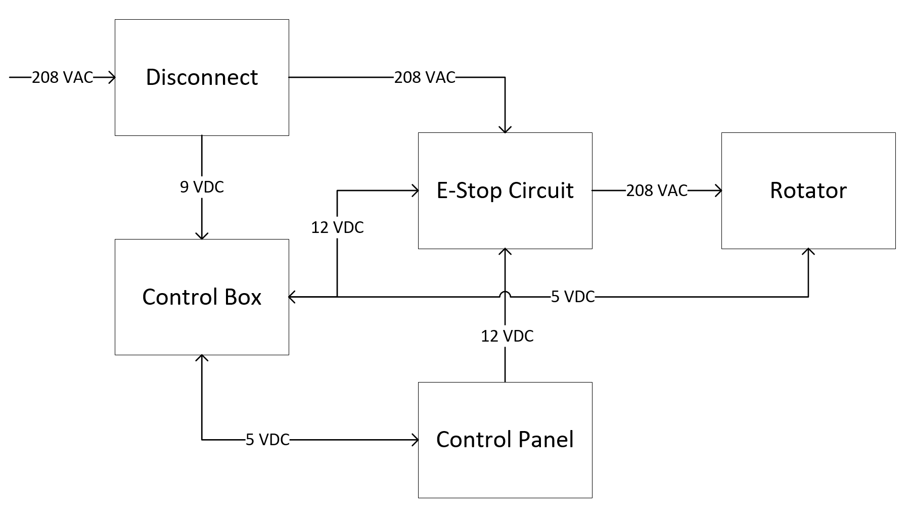

Operator Panel

Figure ‑ - System Block Diagram

### System Description

This section introduces the Disconnect Box, Control Box, Operator Panel, and Rotator systems. This includes high-level descriptions of the hardware, main functionality, and interfacing.

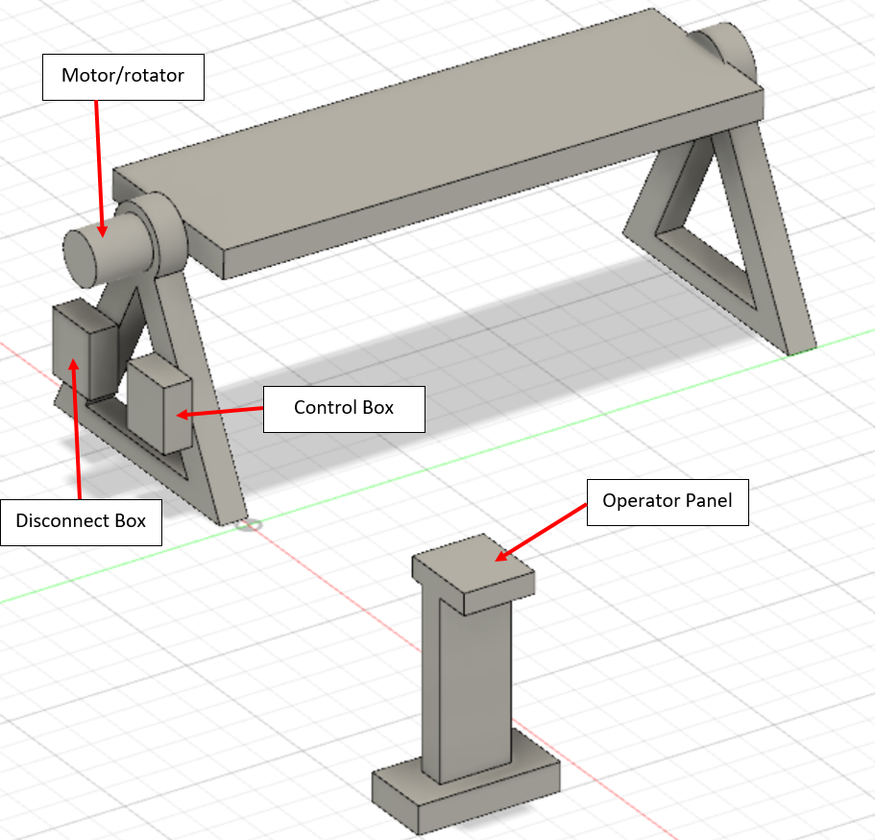

Figure ‑ - System Model

#### Disconnect Box

The disconnect box is a steel enclosure which steps 600 VAC input from Doepker’s facilities down to 208 VAC. It houses the overload protection and main disconnect and contains an E-Stop relay used to prevent AC voltage from going to the Rotator subsystem if the emergency stop is activated. The subsystem is designed to be attached to the system “A” frame.

#### Control Box

The Control Box subsystem is a steel enclosure which contains the microcontroller. The Control Box performs the computing operations in the overall system by taking user input from the Operator Panel and driving the motor in the Rotator. It also features a power and calibration button, used to turn on/off and set a home button respectively. The box is physically connected to each subsystem. The box takes 208 VAC input, which is converted to 12 VDC. 12 VDC or 5 VDC control signals are sent to the Operator Panel, emergency stop relay, and a motor control driver. The Control Box is mounted onto the primary “A” frame of the system.

#### Operator Panel

The Operator Panel subsystem is used by the operator to control the system. It provides the operator with the ability to perform all system rotation operations. The panel is mounted onto a stand, which is connected to the system by a 10ft long flexible cord which powers the panel and sends user inputs to the Control Box. The panel itself is a steel enclosure with an assortment of control buttons and switches on the front which are used to operate the system. The Operator Panel is powered by 5 VDC supplied by the Control Box.

#### Rotator

The Rotator consists of a motor, encoder, and a gear reducer. The motor used is a servo motor, which has a built-in encoder. The encoder provides closed loop feedback signals to provide speed/position information to the microcontroller in the Control Box. The gear reducer is used to step down the motor’s speed of rotation, simultaneously increasing the torque to high enough levels to rotate and attached load. The output shaft of the gear reducer will interface with a welding table provided by the client. These components are mounted to the top of the “A” frame.

## Detailed System Design

The purpose of this section is to discuss in detail the hardware design of the system. The design of the Control Box, Operator Panel, and Rotator will be explored here.

### Control Box

The Control Box is a steel enclosure which contains the Arduino Uno microcontroller, motor driver and E-stop circuit. It is mounted onto the primary frame and can be easily detached using standard tools. The front of the enclosure may be opened for maintenance procedures, which may include reprogramming the microcontroller or replacing any components.

There are power and calibration buttons located on the side of the box, which are used to turn on/off the system and set a “home” position which can be easily rotated to from any angle using the Operator Panel.

The Arduino Uno board is based on the ATmega328P microcontroller. It can perform all the computing required to operate the system using the onboard I/O pins. The pins are used to receive user input from the Operator Panel and Control Box, and to drive the motor driver. It is programmed with the system software, which regulates the timing and duration of which the table will be rotated. Finally, the Arduino board sends a 5 VDC signal to the E-Stop Circuit to engage the E-stop relay. If an E-stop has been enabled in the system, it will then report to the user via the Operator Panel.

The board takes 208 VAC input, which is provided by the Disconnect Box and converts it to 12VDC. It outputs 5 VDC to the Operator Panel to power the LED and buzzer on the operator panel.

### Operator Panel

The Operator Panel is a steel enclosure which contains most of the user input interfacing for the system, powered entirely by 5 VDC from the microcontroller. The panel consists of an assortment of buttons to control the rotation of the system. To operate the system, the operator must hold down a safety button which helps prevent unintended rotation.

The panel also has an LED and buzzer, turned on in unique combinations to provide the operator with information on the state of the system.

Finally, the Operator Panel features an E-stop button to allow the operator to override the system operations and shut off power to the Rotator subsystem. The E-stop button will not shut off power to the microcontroller to prevent any damage from being caused by a sudden power removal.

### Rotator

The Rotator subsystem contains a motor, encoder, and gear reducer. It is mounted to the top of the “A” frame and enables the system to rotate the load. The subsystem takes 208 VAC from the Disconnect Box to power the motor and 12 VDC from the Control Box to signal the direction and speed of the motor.

The motor used is an integrated servo motor from Teknic. It provides superior performance while allowing for simple integration with the microcontroller. The motor will be connected to a gear reducer with gear ratio of at least 360:1 to provide a torque of at least 1530 Nm. The output of the gear reducer is connected to the positioner table. Both the gear reducer and positioner table are to be provided by Doepker Industries.

### A Frames

The “A” frames which the system will be mounted onto are designed by Doepker Industries. The system is designed to be able to mount to the frames without the use of specialty tools.

### Technical Specifications

The system is designed to meet the following technical specifications listed in Table 5‑1:

|  |  |  |
| --- | --- | --- |
| Specification | Value | Comments |
| Static Torque | TBD | Break force unknown at time of writing. |
| Dynamic Torque | 2460 Nm |  |
| RPM | 0 – 5.2 RPM | Can be controlled to any RPM in this range. |
| Load Offset | TBD | Determined by attached table. |

Table ‑ - System Specifications

## System Operation

### System Software

The system’s software is run on the Arduino Uno microcontroller board. It is programmed in C++ into the board’s ATmega328 microcontroller and controls rotating operations. The board is a popular microcontroller and was selected for its reliability and ease of use.

The system’s rotating operations may only be activated from the Operator Panel. It operates using states to determine what the system can do at a given time. A software state diagram is shown below in Figure 5‑3.



Figure ‑ - Software State Diagram

Each system state is described below:

* **Power State** – The system is powered off and no operations may be performed.
* **Standby State** – The default state of the system. The system is powered on, but no operations may be performed until the operator depresses the safety button.
* **Running State** – The system is enabled to perform all rotation operations. It will stay in this state if the safety button remains depressed or the E-stop is not activated.
* **E-Stop State** – The system is shifted to E-stop state when the E-stop button is activated. In the E-stop state, system operations cannot be performed until the E-stop button is deactivated and the system is reset.
* **Reset State** – The system shifts to the Reset state from the E-stop state when the E-stop is deactivated. The system is non-operational in this state and requires the operator to press the reset button to shift back into the Standby state.

It is important to note that while the Standby and E-stop state perform the same function of preventing rotation operations, the Standby state applies a software lock to the motors while the E-stop state cuts power to the motor, applying a hardware lock on the system.

### System Operations

The system takes user input from the Operator Panel and the Control Box and it provides system status from the Operator Panel.

#### User Inputs

Each form of user input is described below. See Figure 5‑4 for a mock-up of the Operator Panel:

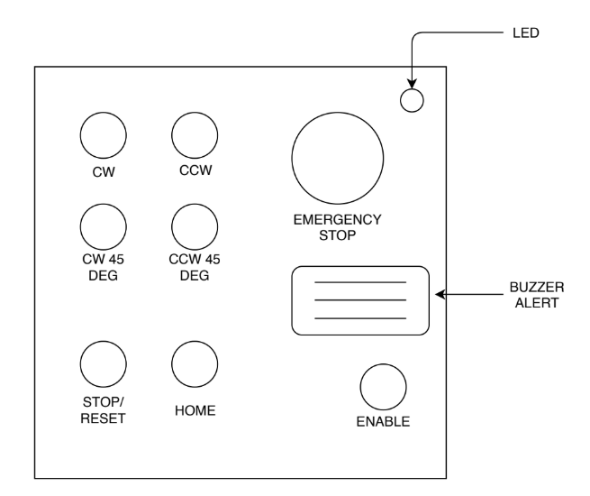

Figure ‑ - Operator Panel Layout

**Control Box:**

* **Power Switch** – located on the front of the box. Used to power on and off the system.
* **Calibration Button** – located on the front of the box. Used to set a home position in the system. This stores the current angular position of the system in the microprocessor, which is utilized by the home button on the Operator Panel. Overwrites the previous home position when pressed.

**Operator Panel:**

* **Rotate CW Button** – located on the front of the panel. Rotates the system in the clockwise direction around the horizontal axis. Figure 5‑5 illustrates how the rotation direction is defined.
* **Rotate CCW Button** – located on the front of the panel. Rotates the system in the counterclockwise direction.
* **Rotate 45° CW Button** – located on the front of the panel. Rotates the system 45° in the clockwise direction.
* **Rotate 45° CCW Button** – located on the front of the panel. Rotates the system 45° in the counterclockwise direction.
* **Home Button** – located on the front of the panel. Rotates the system to the home angular position.
* **Safety Button** – located on the front of the panel. The safety button must be depressed while performing rotating operations and shifts the system to the Running State.
* **Stop/Reset Button** – located on the front of the panel. Pressing the button stops the system from rotating during the running state. When in the E-stop state, pressing this button puts the system back into the Standby state.

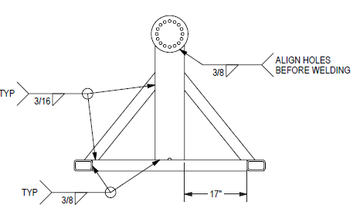

Figure ‑ - System Rotation Direction

#### Operator Feedback

The system provides the operator with visual and audio feedback using an LED and buzzer, located on the front of the Operator Panel. The LED is used to depict the current state that the system is in, while the buzzer is used to alert anyone in vicinity of the system that it is rotating or experiencing an error.

A description of the LED and buzzer’s behaviour for each state is described below in Table 5‑2:

|  |  |  |  |
| --- | --- | --- | --- |
| State | LED Behaviour | Buzzer Behaviour | Comments |
| Power | Off | Off |  |
| Standby | Solid Amber | Off |  |
| Running | Blinking Green | Long Beeping | Only beeps while the table is rotating. Beeps 2s on/off continuously. |
| E-Stop | Blinking Red | Short Beeping | Beeps 0.5s on/off continuously. |
| Reset Required | Solid Red | Medium Beeping | Beeps 1s on/off continuously. |

Table ‑ - Behaviour of LED and Buzzer for each System State

The buzzer will be activated in specific patterns for situations where the system experiences an error. Examples of errors include if the attached load is too heavy or if the system has rotated less/more than expected. The buzzer patterns are TBD.

#### Home Function

The system features a home position function, which allows the operator to quickly recall a home angular position. The home position is stored on the microcontroller and updated each time the calibration button on the control box is pressed. The purpose of this function is to remove the need for the operator to carefully set the system to a commonly used angular position by allowing the operator to simply press a recall button on the control box instead. The safety button must be depressed first to use this function.

### E-Stop Functionality

The E-stop of the system performs a category 0 stop as defined by the NFPA 79 standard. When an E-stop is engaged from the Operator Panel, the E-Stop Circuit immediately stops 208 VAC power from reaching the Rotator subsystem, stopping all rotation operations immediately. However, power is still supplied to the rest of the system which comprises the Control Box and Operator Panel. The E-Stop Circuit notifies the microcontroller that an E-stop is active, which then will notify the operator that an E-stop is on using the LED and buzzer on the Operator Panel (see Table 5‑2).

To reactivate the system after an E-stop, the E-stop button must first be disengaged. Once the Operator Panel indicates that the system requires a reset (Table 5‑2), the operator may press the Stop/Reset button on the Operator Panel to re-enable system operations.

# System Test Plan

## Verification Process

### Introduction

The overall objective of the verification process is to thoroughly examine all parts of the Doepker Industries Robotic Positioner at the software, hardware and system levels to verify their compliance with the system requirements. To this end, a comprehensive suite of tests is planned.

The verification program is characterized by a number of major features:

* Detailed tests are performed according to authorized test procedures.
* Test results are to be compared to the predetermined success criteria, which are derived from the appropriate specifications. These criteria are defined in the test procedures.
* Test results and test equipment information is recorded in the authorized test procedure.
* Analyses, inspections, and dry run specific tests are completed prior to FAT and are reviewed with the client.

Formal system-level acceptance tests will be performed at the University of Saskatchewan’s College of Engineering. The client will be requested to formally witness these tests and sign off the appropriate test procedure results once the tests are completed.

### Verification Methods

Verification methods are defined as follows:

* Analysis – Requirements are verified by applying indirect methods such as mathematical analysis, modeling, simulation, similarity assessments, review of design, and validation of records.
* Inspection – Requirements are verified by direct visual observation of passive characteristics, without the use of specialized equipment or services.
* Test – Requirements are verified by measurement of quantitative characteristics during or after the controlled application of stimuli under appropriately controlled conditions, or by direct visual observation of active qualitative characteristics.

### Verification Strategies

The assignment of verification methods is identified in the Robotic Positioner System Requirements Matrix.

* Verification by Analysis and Inspection. Verification by these methods will be completed prior to or during system integration testing. The verification results will be available for review.
* Verification by Test. This verification will be included in a completed test procedure. The test method will include demonstrations of functional requirements that are not meant to be exhaustive, but rather are meant to provide examples of typical operation as applicable to each system requirement

### Doepker Industries Notification

All acceptance tests will be scheduled in advance. Doepker Industries will be given 1 week notice of any acceptance tests to be performed. Doepker Industries may attend any test at their discretion. Doepker Industries will be requested to formally witness the acceptance tests and sign off the appropriate test procedure results once the tests are completed.

The acceptance test procedures will be written and submitted to Doepker Industries 2 weeks prior to the start of the testing. After completing the corrections or modifications requested by Doepker Industries, the approved test procedure becomes the controlling document for executing the acceptance tests.

## Levels of Testing

### Overall Test Process

The overall test process is illustrated in Figure 6‑1. This figure illustrates the major activities included in the process and the sequence in which they are to be performed.



Figure ‑ - System Testing Process

### System-Level Testing

#### System Integration and Testing

The system integration tests are designed to eliminate anomalies from the system and to demonstrate that the assembled system meets the performance specifications. To meet this objective the system testing sequence is to:

* Verify the software and hardware independently.
* Integrate the hardware, software, and test equipment and conduct integration tests on the integrated equipment.
* Perform verification tests in accordance to the FAT procedure document.

#### FAT

Factory Acceptance Testing will be performed at the College of Engineering at the University of Saskatchewan prior to shipment. The purpose of these tests is to verify that the system meets the operational specifications prior to shipping the system to site.

The FAT procedures to be performed are located in Section 6.3. Section 6.4 contains the formal test procedures for the Doepker Industries Robotic Positioner. During FAT, the system requirements will be reviewed with the client to examine how each requirement is verified.

#### FAT Acceptance Review

After the FAT has been completed, a review meeting will be held. The purpose of this meeting is to review the test results and discuss any anomalies identified during the tests.

#### FAT Results

The results of the FAT tests and the minutes of the Factory Acceptance Review meeting will be formalized in a Factory Acceptance Report. This report will be issued to Doepker Industries within 1 week of the completion of the tests. It will include a copy of the test results and a summary of the testing.

#### Site Installation

Once the system has arrived on site, testing will be performed to verify that no shipping damage has occurred. Once the installation checks have been successfully completed, the on-site acceptance testing will begin. A subset of the FAT procedure will be completed under client supervision. A meeting will be conducted to discuss any anomalies found during site testing, and an action plan to resolve all anomalies will be developed.

### Required Test Equipment

The equipment listed in Table 6‑1 will be required to perform system-level testing.

Table ‑ - Test Equipment

|  |  |  |  |
| --- | --- | --- | --- |
| **Item** | **Vendor** | **Description** | **Quantity** |
| TBD |  |  |  |
|  |  |  |  |
|  |  |  |  |

### Anomalies – Log Items

Each anomaly detected during testing that is significant enough to warrant tracking shall be documented and tracked as a log item. Each log item documents one anomaly and shows the date, the originator’s name, the test phase that the anomaly was detected in and the category of the anomaly. In addition, the log item provides a concise and complete description of the problem and a suggested course of action to clear the anomaly. A log item is removed once the anomaly has been corrected and the fix is verified. A Google spreadsheet will be used to track log items in real time. Doepker Industries will be provided a link to view the spreadsheet.

## Factory Acceptance Testing

### Introduction

The formal system test procedures describe the purpose of the test, the configuration of the test, step-by-step procedures for the test, and acceptance criteria. Section 6.4 contains the formal test procedures for the Doepker Industries Robotic Positioner.

Each test procedure is written and reviewed prior to use. Each test procedure is prepared to a standard format. This format contains the following sections:

1. Title Page. Identifies the test procedure, who conducted the test, who approved the test, and the date the test was performed.
2. Scope. Defines what the test procedure is to be used for and a general statement on the scope of the test.
3. Required Test Equipment. Provides a list of the test equipment required to perform the test. Space is provided within this table to identify the actual test equipment used during the test.
4. Detailed Test Procedure. Contains the step-by-step procedure for performing the test. Included is space for verification and recording of measurement results. Where applicable, pass/fail criteria are included in the procedure. System test procedures are developed based on the customer’s requirements.

## Doepker Industries Robotic Positioner Test Procedures

### Purpose

The purpose of this procedure is to verify that the performance and function of the Doepker Industries Robotic Positioner meets its requirements as specified in Robotic Positioner System Requirements Matrix.

### Test Failures

Minor problems encountered during testing shall be corrected and the test restarted from the last successful step. If major problems are encountered, each problem shall be recorded on a log item form, clearly indicating which test step has failed and what the configuration is so that the failure scenario can be recreated at a later time. The log item number shall be recorded in the procedure, next to the applicable test step for future reference.

### Test Preparation

#### Required Test Equipment

Fill in the information in Table 6‑2 for each piece of test equipment used for the system tests.

Table ‑ - Test Equipment

|  |  |  |  |
| --- | --- | --- | --- |
| **Description** | **Vendor** | **Model** | **Serial Number** |
| 500 kg load | TBD | TBD | TBD |
|  |  |  |  |
|  |  |  |  |

#### Test Setup

Figure 6‑2 shows the test setup. Configurations and settings that differ for each test are detailed in the test procedure.

| Step | Action | Verify |
| --- | --- | --- |
|  | Verify that the equipment is configured as per Figure 6‑2. Ensure that no load is attached to the table and the system is connected to a 600 VAC source. | ______ |

| Test Setup Results |
| --- |
| Comments: |
| Signoff:  Group #5 Representative Signature: ____________  Doepker Industries Representative Signature: ____________  Date: ____________ |

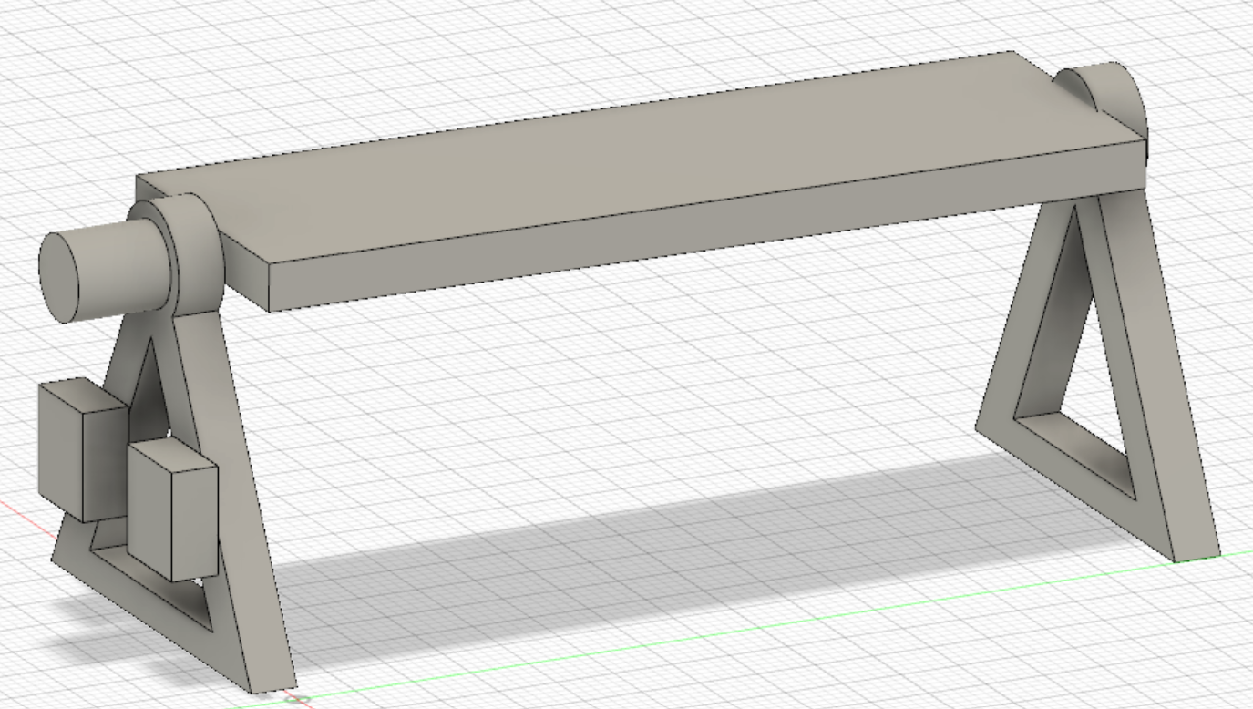

Figure ‑ - Test Setup

#### Requirements Verified by Inspection

The following review can be conducted any time during FAT. It is not a prerequisite to starting test.

| Step | Action | Verify |
| --- | --- | --- |
|  | Review the System Requirements Matrix to confirm that all those requirements to be verified by inspection have been verified. | ______ |

| System Inspection Results |
| --- |
| Comments: |
| Signoff:  Group #5 Representative Signature: ____________  Doepker Industries Representative Signature: ____________  Date: ____________ |

### Detailed Procedures

#### Test No. 1 – Load Testing

##### Objective

The objective of this test is to verify that the system meets the following rotation design requirements:

|  |  |
| --- | --- |
| **Requirement** | **Description** |
| RD-1 | The system shall continuously rotate a load 360° around the horizontal axis. |
| RD-3 | The system shall support at minimum 1177 newton-meter (N m) of dynamic torque. |
| RD-4 | The system shall support at minimum 941 N m of static torque. |
| RD-5 | The system shall support a load of maximum 500 kilograms (kg) weight. |
| RD-9 | The load shall remain fixed along the rotational axis when the system is not rotating. |
| HD-2 | The system shall remain stationary during operation. |

##### Configuration

Configure the test set-up as per Figure 6‑2 and ensure the following additional set-up is completed:

* The positioner table is set to an angle where a load may be attached parallel to the ground.
* There is no load attached to the positioner table.
* The system is turned on and in standby mode (status LED on operator panel is lit in an amber color and the buzzer is off).

##### Test Steps

| Step | Action | Verify |
| --- | --- | --- |
|  | Obtain a load that is around 500kg in mass. The load must be able to be attached securely to the positioner table without impeding rotation. Record the weight of the load below:  Load weight = ______ kg | ______ |
|  | Attach the load so that the center of mass is at the middle of the positioner table. | ______ |
|  | Calculate the static and dynamic torque from the weight and vertical center of mass of the load.  The vertical center of mass is measured from the center of mass of the load to the table surface.  Vertical Center of Mass = ______ m  Static Torque = Load Weight * Vertical Center of Mass = ______ Nm  Dynamic Torque = Power/Speed = ______ Nm | ______ |
|  | Depress and hold the safety button on the operator panel. Press and hold the “ROTATE CW” button until the load has completed approximately 2 revolutions. | ______ |
|  | Verify that the load is still attached securely to the table and has not shifted in position. | ______ |

| Load Testing Test Results |
| --- |
| Comments: |
| Signoff:  Group #5 Representative Signature: ____________  Doepker Industries Representative Signature: ____________  Date: ____________ |

#### Test No. 2 – Rotation Speed Testing

##### Objective

The objective of this test is to verify that the system meets the following rotation design requirements:

|  |  |
| --- | --- |
| **Requirement** | **Description** |
| RD-7 | The system shall rotate at a minimum speed of 1.0 rotations-per-minute (rpm). |
| RD-8 | The system shall rotate at a maximum speed of 5.0 rpm. |
| HD-2 | The system shall remain stationary during operation. |

##### Configuration

Configure the test set-up as per Figure 6‑2 and ensure the following additional set-up is completed:

* The load from Test No. 1 – Load Testing is attached to the positioner table.
* The system is turned on and in standby mode (status LED on operator panel is lit in an amber color and the buzzer is off).

##### Test Steps

| Step | Action | Verify |
| --- | --- | --- |
|  | Record the current time and angle at which the positioner table is at. Immediately proceed to the following step.  Time1 (hh:mm:ss): ____________  Angle1: ______° | ______ |
|  | Depress and hold the safety button on the operator panel. Press and hold the “ROTATE CW” button until the load has completed at least 2 revolutions. | ______ |
|  | Record the time and angle at which the positioner table is at immediately after step 2.  Time2 (hh:mm:ss): ____________  Angle2: ______° | ______ |
|  | Calculate the rotations-per-minute using the following equation:  Delta_time = Time2 - Time1 = ______ seconds  Rotations-per-minute = (Angle2 - Angle1)/( Delta_time) = ______ rpm | ______ |
|  | Verify that the rotations-per-minute calculated in step 4 is between 1.0 and 5.0 rpm. | ______ |
|  | Verify that the system remained stationary during operation. | ______ |

| Rotation Speed Test Results |
| --- |
| Comments: |
| Signoff:  Group #5 Representative Signature: ____________  Doepker Industries Representative Signature: ____________  Date: ____________ |

#### Test No. 3 – E-Stop and Reset Testing

##### Objective

The objective of this test is to verify that the system meets the following rotation design requirements:

|  |  |
| --- | --- |
| **Requirement** | **Description** |
| SR-1 | The system shall have an easy-to-access emergency stop button, which stops all system operations when pressed. |
| SR-2 | The system shall have a switch to disable/enable rotation operations. |
| SR-3 | The system shall audibly alert the operator when rotating. |
| UIR-4 | The system’s operator panel shall indicate if the system is rotation locked. |
| UIR-5 | The system shall have an on/off button and indicator. |

##### Configuration

Configure the test set-up as per Figure 6‑2 and ensure the following additional set-up is completed:

* The system is turned off.

##### Test Steps

| Step | Action | Verify |
| --- | --- | --- |
|  | Turn the system on by pressing the “ON/OFF” button on the control box. Verify that the system enters standby mode (status LED on operator panel is lit in an amber color and the buzzer is off). | ______ |
|  | Depress and hold the safety button on the operator panel to put the system into running mode. Verify that the LED is blinking on/off in a green color. | ______ |
|  | Press and hold the “ROTATE CW” button. Verify that the table is rotating in the clockwise direction and the buzzer is beeping while the button is depressed. | ______ |
|  | Release the “ROTATE CW” button. Verify that the table stops rotating and the buzzer stops beeping. | ______ |
|  | Press the “ROTATE CCW 45” button. Verify that the table is rotating in the counter-clockwise direction and the buzzer is beeping during the rotation (2s on/off). | ______ |
|  | While the table is rotating from step 4, activate the E-Stop button on the operator panel. This is done by lifting and twisting the button. | ______ |
|  | Verify that the table immediately stops rotating and the system exhibits the following behaviour:   * Operator Panel LED is blinking in a red color * Operator Panel buzzer is beeping rapidly (0.5s on/off) | ______ |
|  | Release the E-Stop button on the operator panel. Verify that the system enters the reset state by checking that the LED shifts to a solid red color and the buzzer beeps in 1s intervals. | ______ |
|  | Depress the reset button on the operator panel and verify that the system enters the standby mode immediately (status LED on operator panel is lit in an amber color and the buzzer is off). | ______ |

| E-Stop and Reset Test Results |
| --- |
| Comments: |
| Signoff:  Group #5 Representative Signature: ____________  Doepker Industries Representative Signature: ____________  Date: ____________ |

#### Test No. 4 – System Recall Testing

##### Objective

The objective of this test is to verify that the system meets the following rotation design requirements:

|  |  |
| --- | --- |
| **Requirement** | **Description** |
| RD-2 | The system shall be able to recall and rotate to a pre-set angular position. |
| RD-10 | The system shall rotate to angle positions with a resolution of maximum 1°. |
| UIR-6 | The operator panel shall have buttons to rotate 45˚ clockwise and counterclockwise from the current position. |

##### Configuration

Configure the test set-up as per Figure 6‑2 and ensure the following additional set-up is completed:

* The system is turned on and in standby mode (status LED on operator panel is lit in an amber color and the buzzer is off).

##### Test Steps

| Step | Action | Verify |
| --- | --- | --- |
|  | Record the current angle at which the positioner table is at.  Angle1: ______° (add 360° to this value if it is negative) | ______ |
|  | Depress and hold the safety button on the operator panel. Press the “ROTATE CCW 45” button. | ______ |
|  | Record the angle of the positioner table after the system finishes rotating in the counterclockwise direction.  Angle2: ______° (add 360° to this value if it is negative) | ______ |
|  | Verify that the system has rotated 45° in the counterclockwise direction by calculating the angular error. Verify that the angular error is within the passing criteria of +1°.  ΔAngle = Angle2 – Angle1 - 45°= ______° | ______ |
|  | Depress the “CALIBRATE” button on the control box to set the current position to be the “home” position. | ______ |
|  | Depress and hold the safety button on the operator panel. Press the “ROTATE CW 45” button. | ______ |
|  | Record the angle of the positioner table after the system finishes rotating in the clockwise direction.  Angle3: ______° (add 360° to this value if it is negative) | ______ |
|  | Depress and hold the safety button on the operator panel. Press the “HOME” button on the operator panel. | ______ |
|  | Verify that the system rotates the table back to the home position of Angle2. | ______ |
|  | Verify that the system has rotated 45° in the clockwise direction by calculating the angular error. Verify that the angular error is within the passing criteria of +1°.  ΔAngle = Angle3 – Angle2 + 45°= ______° | ______ |

| System Recall Test Results |
| --- |
| Comments: |
| Signoff:  Group #5 Representative Signature: ____________  Doepker Industries Representative Signature: ____________  Date: ____________ |

#### Test No. 5 – Unbalanced Load Test

##### Objective

The objective of this test is to verify that the system meets the following rotation design requirements:

|  |  |
| --- | --- |
| **Requirement** | **Description** |
| RD-6 | The system shall support a load offset of maximum 0.15 meters. |

##### Configuration

Configure the test set-up as per Figure 6‑2 and ensure the following additional set-up is completed:

* The positioner table is set to an angle where a load may be attached parallel to the ground.
* The system is turned on and in standby mode (status LED on operator panel is lit in an amber color and the buzzer is off).

##### Test Steps

| Step | Action | Verify |
| --- | --- | --- |
|  | Obtain a load that is around 500kg in mass. The load must be able to be attached securely to the positioner table without impeding rotation. Record the weight of the load below:  Load weight = ______ kg | ______ |
|  | Attach the load so that the center of mass is 0.15m from the middle of the positioner table. | ______ |
|  | Depress and hold the safety button on the operator panel. Press and hold the “ROTATE CCW” button until the load has completed approximately 2 revolutions. |  |
|  | Verify that the load is still attached securely to the table and has not shifted in position. | ______ |

| Unbalanced Load Test Results |
| --- |
| Comments: |
| Signoff:  Group #5 Representative Signature: ____________  Doepker Industries Representative Signature: ____________  Date: ____________ |

# Project Planning

## Introduction

This section is used to provide detailed information on the current status of the Doepker Industries Robotic Positioner system for the EE/CME 495 class for 2019-2020. The current project schedule is presented, along with the current risks faced. In addition, a system bill of materials and overall project budget is provided.

## Risks to Project Performance/Schedule

The project risks for this project have been reduced from those presented in CD2 – EE495/CME495 Robotic Positioner Project Plan. The following risks were alleviated:

* The risk of having long equipment lead times have been largely avoided by selecting components from vendors with shorter lead times. Components have been ordered by Doekper Industries and are expected to arrive in December.
* The risk of outsourcing production to Doepker Industries is gone as the system has now been designed and the design schematics have been provided for manufacturing.
* The risk of the system being operated in unexpected environments has been avoided by defining with the client what kind of environment the system shall be designed to operate in.

A list of risks that may impact the quality of the final product or project schedule include:

* Component reliability - there is a possibility that the components ordered will not be reliable due to being new products, or due to being specialty components which may not have been tested to the extent of a component meant for larger market.
  + This can be mitigated by ordering components from more experienced vendors in the market, as well as avoiding ordering products that were recently introduced to the market.

## Milestones

Listed in Table 7‑1 are the major project milestones and their expected completion dates. The dates have been adjusted from the dates listed in CD2 – EE495/CME495 Robotic Positioner Project Plan to present more realistic milestone dates:

Table ‑ - Project Milestones

|  |  |  |
| --- | --- | --- |
| **Milestone** | **Date** | **Completed** |
| Begin Unit Production | December 26, 2019 |  |
| User Manual | January 26, 2019 |  |
| System Verification Plan | January 6, 2020 | 100% |
| Perform Factory Acceptance Testing | February 13, 2020 |  |
| Final Report | April 10, 2020 |  |

## Gantt Chart

See below for an image of the project’s Gantt Chart including the remaining tasks left to be completed for the project. If desired, a Microsoft Project or PDF file of the Gantt Chart may be requested (email [thomas.hu@usask.ca](mailto:thomas.hu@usask.ca) to request a copy).



Figure ‑ - Project Gantt Chart

## Work Breakdown Structure

Attached below in Table 7‑2 is the work breakdown structure for the remainder of the project, which details the team member responsible for each task in designing the system and how many hours are budgeted for each task. It is important to note that the task numbers of the table are aligned with the task numbers of CD2 – EE495/CME495 Robotic Positioner Project Plan, to prevent confusion in future project management updates.

Table ‑ - Work Breakdown Structure

|  |  |  |  |  |  |  |  |
| --- | --- | --- | --- | --- | --- | --- | --- |
| **Task Number** | **Task Name** | **Assignee** | **Hours Budgeted** | **Task Start** | **Task Deadline** | **Predecessor** | **Task Completion** |
| **8** | Acquire System Components | Jordan | 6 | Mon 12/23/19 | Mon 12/23/19 | 5.2.2 |  |
| **9** | Perform System Development | Thomas | 85 | Fri 12/6/19 | Fri 1/17/20 | 5 |  |
| **9.1** | Develop Software | Jason | 25 | Fri 12/6/19 | Fri 12/27/19 |  |  |
| **9.2** | Build Hardware | Jordan | 20 | Thu 12/26/19 | Fri 1/3/19 |  |  |
| **9.3** | Perform System Integration | Thomas | 30 | Mon 1/6/19 | Fri 1/17/20 | 9.1, 9.2 |  |
| **10** | Create System Verification Plan | Thomas | 37.5 | Fri 12/20/19 | Mon 1/6/20 | 4 | 93.3% |
| **10.1** | Define Use Cases | Thomas | 10 | Fri 12/20/19 | Sun 12/22/19 |  | 100% |
| **10.2** | Define Test Cases | Thomas | 10 | Mon 12/23/19 | Fri 12/27/19 | 10.1 | 100% |
| **10.3** | Write Test Procedures | Thomas | 15 | Wed 1/1/20 | Fri 1/3/20 | 10.2 | 100% |
| **10.3.1** | Review Test Procedures with Client | Jordan | 2.5 | Wed 1/1/20 | Fri 1/3/20 |  |  |
| **11** | Perform Acceptance Tests | Thomas | 40 | Mon 1/20/20 | Thu 2/20/20 | 10 |  |
| **11.1** | Perform Integration Testing | Jason | 20 | Mon 1/20/20 | Tue 1/28/20 | 8, 9 |  |
| **11.2** | Review Integration Test Results with Customer | Jordan | 2.5 | Wed 1/29/20 | Wed 1/29/20 | 11.1 |  |
| **11.3** | Perform Factory Acceptance Tests with Client | Thomas | 7.5 | Thu 1/30/20 | Fri 1/31/20 | 11.2 |  |
| **11.4** | Write Factory Acceptance Report | Thomas | 10 | Mon 2/3/20 | Fri 2/7/20 | 11.3 |  |
| **12** | Write User Manual | Thomas | 30 | Fri 12/6/19 | Thu 12/26/19 | 5 |  |
| **13** | Prepare Final Project Presentation and Demonstration | Jason | 40 | Mon 3/2/20 | Fri 3/20/20 | 5, 11 |  |
| **13.1** | Make Final Project Presentation | Jason | 20 | Mon 3/2/20 | Tue 3/10/20 |  |  |
| **13.2** | Review Presentation with Client | Jordan | 1.5 | Wed 3/11/20 | Wed 3/11/20 | 13.1 |  |
| **13.3** | Present Final Project Presentation | Jason | 1 | Fri 3/20/20 | Fri 3/20/20 | 13.2 |  |
| **13.4** | Prepare Project Demonstration | Jordan | 15 | Mon 3/2/20 | Thu 3/19/20 |  |  |
| **13.5** | Demonstrate Project | Jordan | 2.5 | Fri 3/20/20 | Fri 3/20/20 | 13.3 |  |
| **14** | Write Final Project Report | Thomas | 60 | Mon 3/2/20 | Fri 4/10/20 | 11 |  |
| **14.1** | Review Report with Client | Jordan | 2 | Mon 3/30/20 | Tue 4/7/20 |  |  |

## Prototype Costs

Small scale testing using the production microcontroller was conducted to start software development without waiting for component procurement. The prototyping costs are listed below in Table 7‑3 (no tax included):

Table ‑ - Cost of Prototyping

|  |  |  |  |
| --- | --- | --- | --- |
| **Item** | **Unit Price ($ CAD)** | **Quantity** | **Total ($ CAD)** |
| Arduino Uno R3 | 31.60 | 1 | **31.60** |

## System Bill of Materials

The bill of materials for one Robotic Positioner unit is displayed below in Table 7‑4. Taxes are not included.

Table ‑ - Bill of Materials



|  |  |
| --- | --- |
| Supplied by Totally Wired Electric |  |

## Project Budget

It is estimated that 175 hours have been spent working on the project from the dates of September 20, 2019 to December 5, 2019. A rough breakdown of the hours spent during certain time periods is shown below:

Table ‑ - Project Billable Hours

|  |  |  |  |  |
| --- | --- | --- | --- | --- |
| **Project Management Update #1 (09/20/19 – 10/17/19)** | **Project Management Update #2 (10/17/19 – 10/31/19)** | **Project Management Update #2 (10/31/19 – 11/21/19)** | **Remainder of Term**  **(11/12/19 – 12/05/19)** | **Total Hours** |
| 19.5 hours | 24 hours | 57 hours | 74.5 hours | **175 hours** |

Based on the time spent working on the project, it is estimated that the total project cost is **$5,832.62**. This estimate was derived from the average engineering graduate salary of $64,922 (Insightrix Research Inc., 2019). The calculation of hourly wage was made with an assumption that the average engineer works 52 weeks/year and 37.5 hours/week. The hourly wage of each group member is therefore $33.30 an hour.

## Remaining Budget

From the Work Breakdown Structure in Table 7‑2, it is estimated that about **263.5 hours** will be spent working on the project from the time period of December 6, 2019 to April 7, 2020. Therefore, the remaining project budget is **$8,782.25**.

# References

Insightrix Research Inc. (2019). *2019 Salary Survey.* Saskatoon: APEGS.

# Appendix A

This section includes the technical drawings of the microcontroller pinout, motor control circuit, and operator panel circuit. These provide information on how the subsystems will interface with each other.

